|  |
| --- |
|  |
| Xampp server  Ctu buddy |
| |  |  |  | | --- | --- | --- | | Philip | 9/26/23 | CW412 | |

|  |  |  |  |  |  |  |  |  |  |
| --- | --- | --- | --- | --- | --- | --- | --- | --- | --- |
| **Faculty of Information Technology** | | | | | | | | | |
| I declare that I am familiar with, and will abide to the Examination rules of CTU.  PM. POTGIETER    **Signature** | **SUBJECT NAME: SD Foundation**  **SUBJECT CODE: CW412** | | | | | | | | |
| **Formative Assessment 1 Duration**:  **Date**:  **Total Marks**:  **Total pages**: | | | | **Examiner**:  **Moderator:** | | | | |
| **Student number:20231860** | | | | | | | | |
|  |  |  |  |  |  |  |  |  |
| **Surname**: | | | | **Initials**: | | | / | % |

Contents

References 2

***The free web hosting application that we are using is :***

we are using Xampp as our back-end manegment software to manege our website and to to add functionality to the website.

Step1:

Add your website to the xampp directory.Place your website in htdocs folder.Our website name is “Phase2_shadows_2023.”

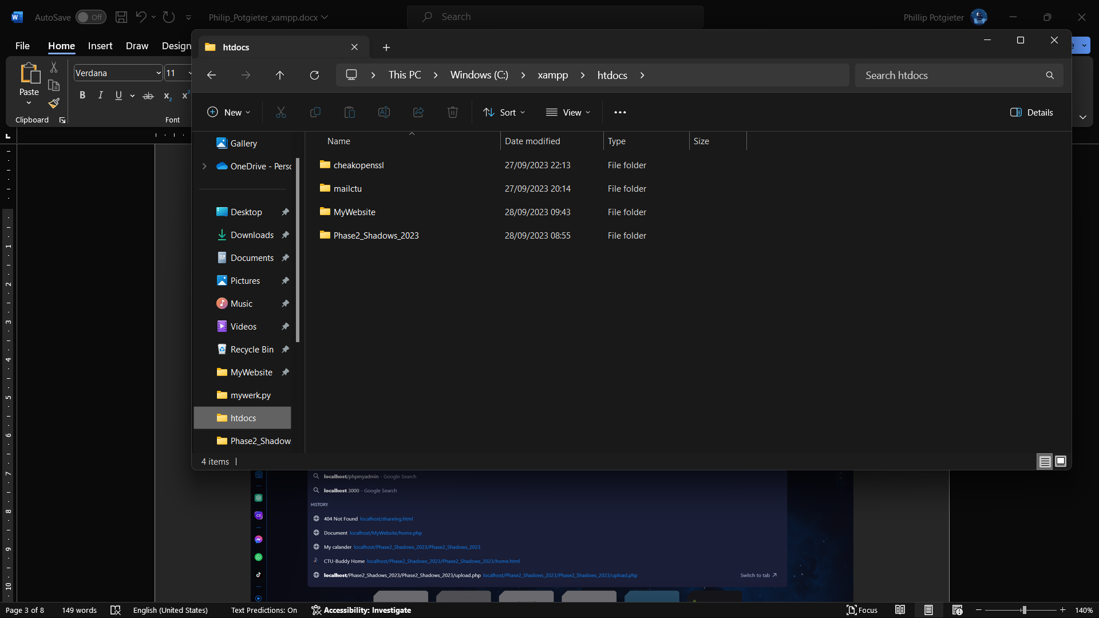

Step2:

Go to your Xampp control panel and clink on the start button for mySql and for Apache,wait for it to start.

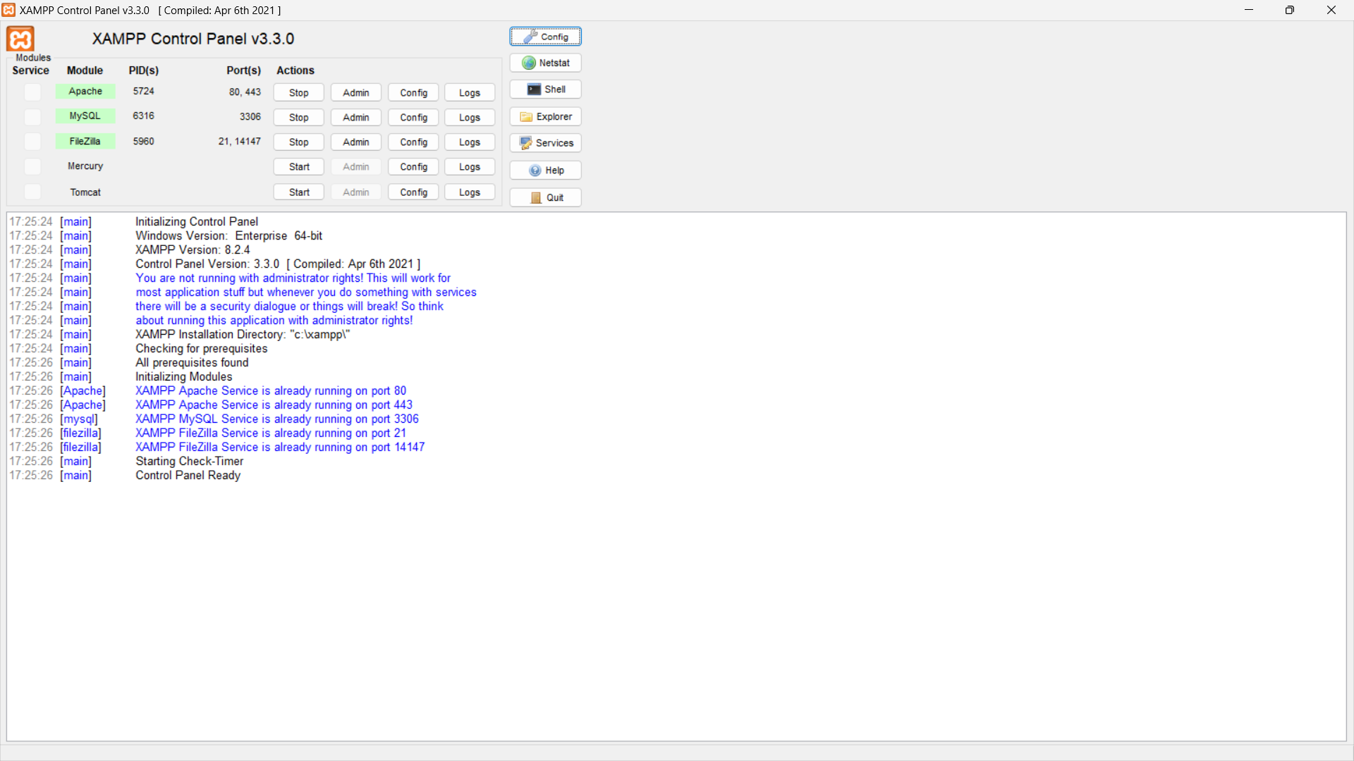

Step3:

Go to your webbrowser.In the search bar type in “localhost” .

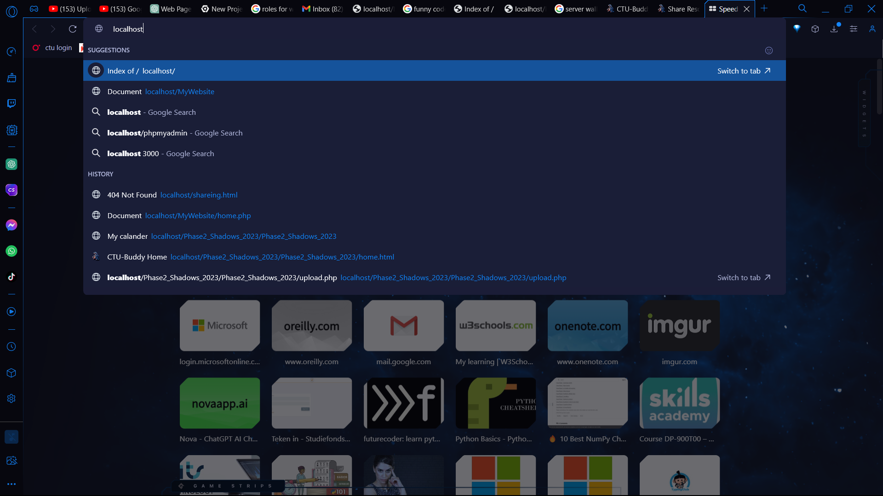

Step4:

Now the main page of Xampp is open .Select the folder you want to open .

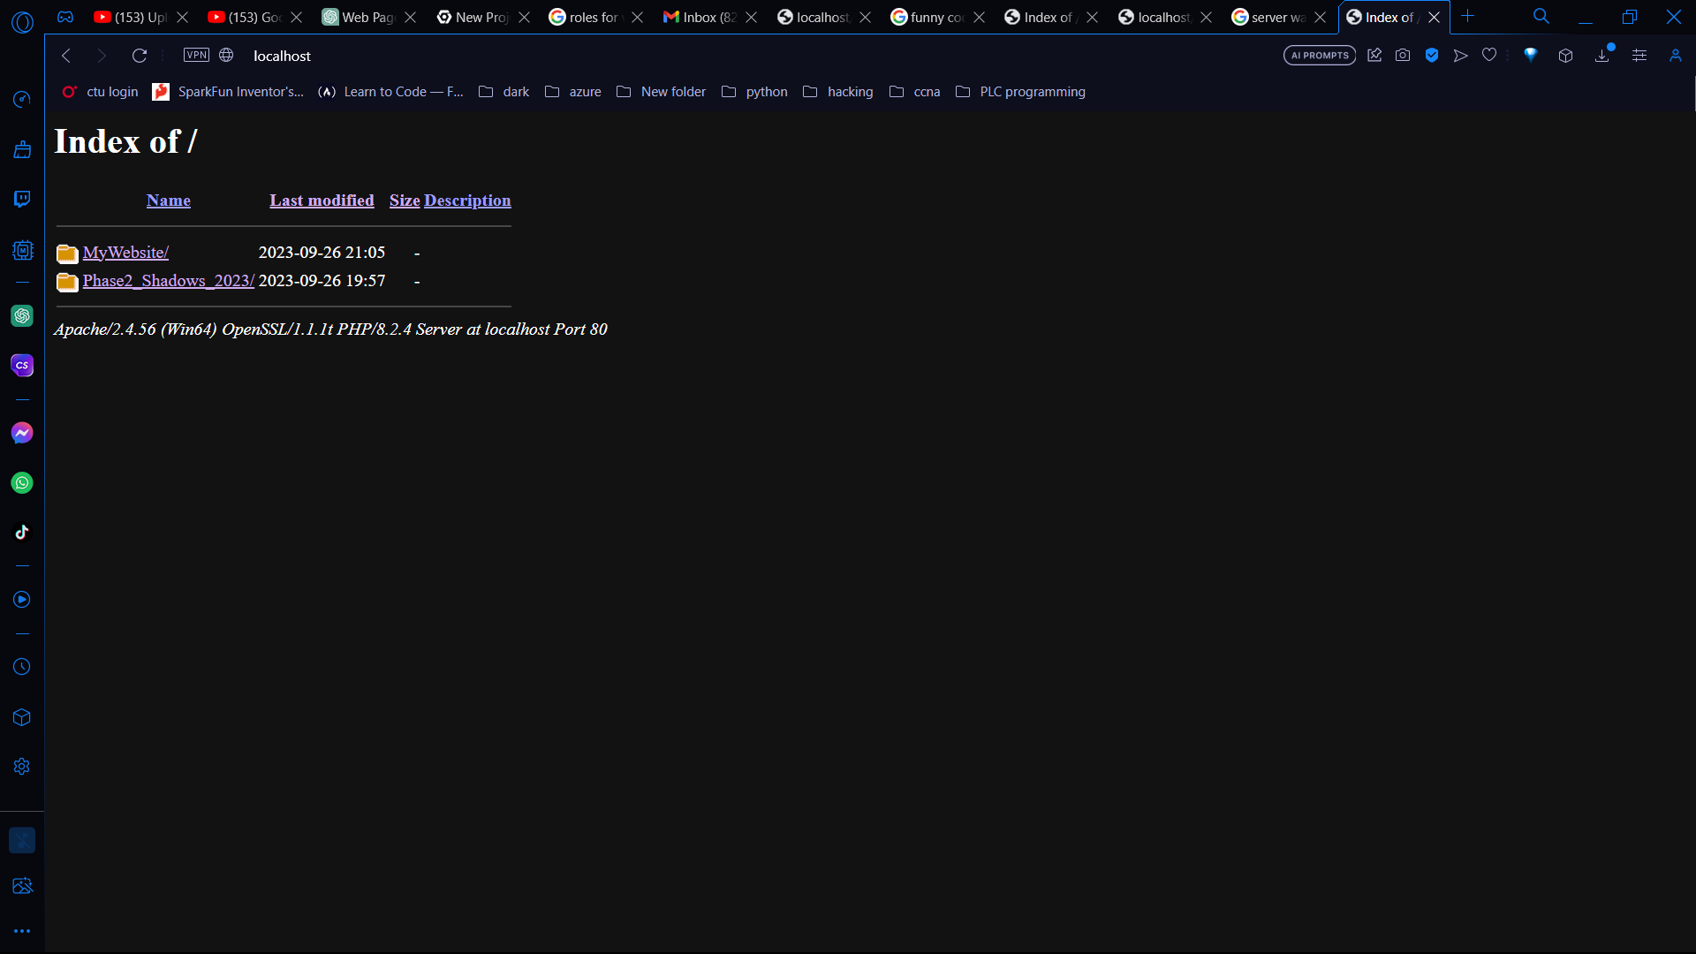

As you can see the website in now running on my localhost

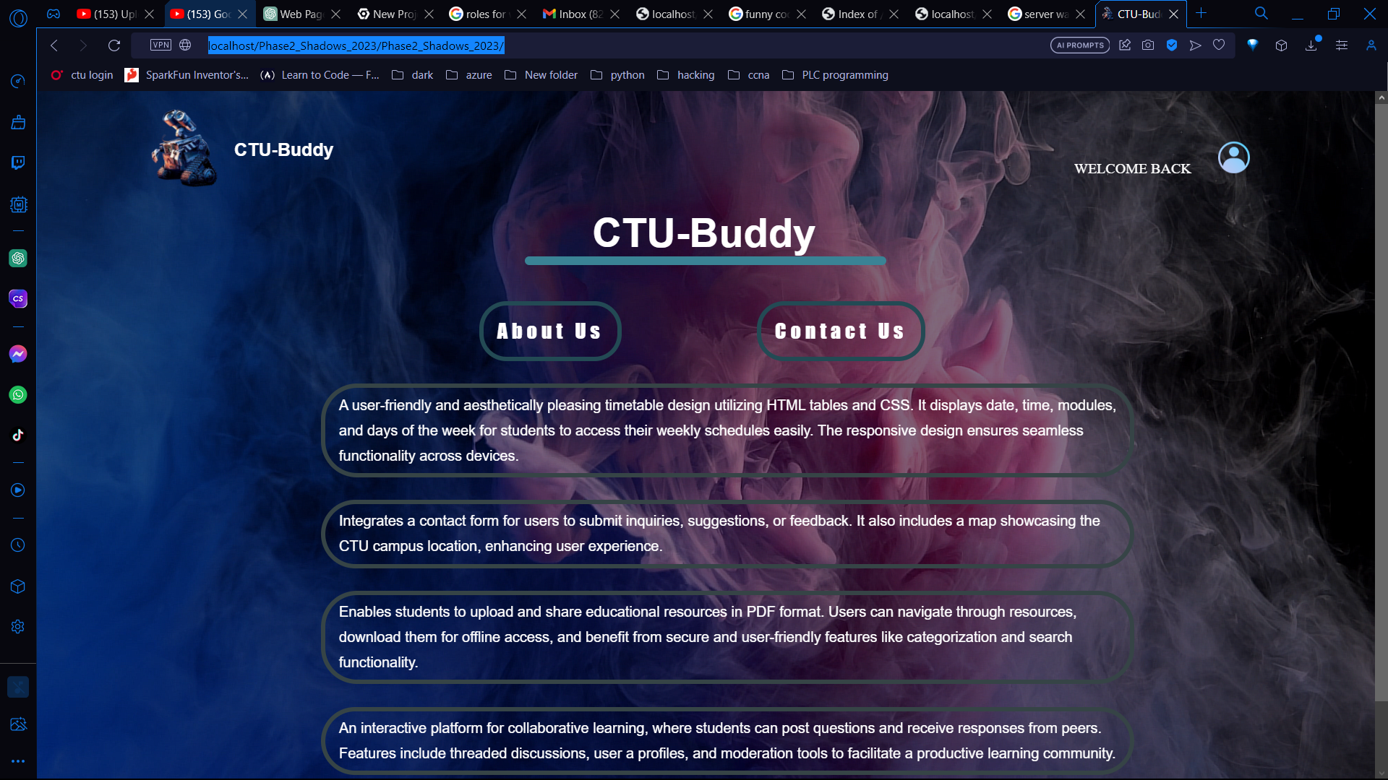

***File upload and download functionality.***

To setup the functionality to upload and to download files. There are some is somethings we need to do.

Step1:

Go to the htdocs folder in the folder select your website folder. The folder of your website is “Phase2_shadows_2023”.

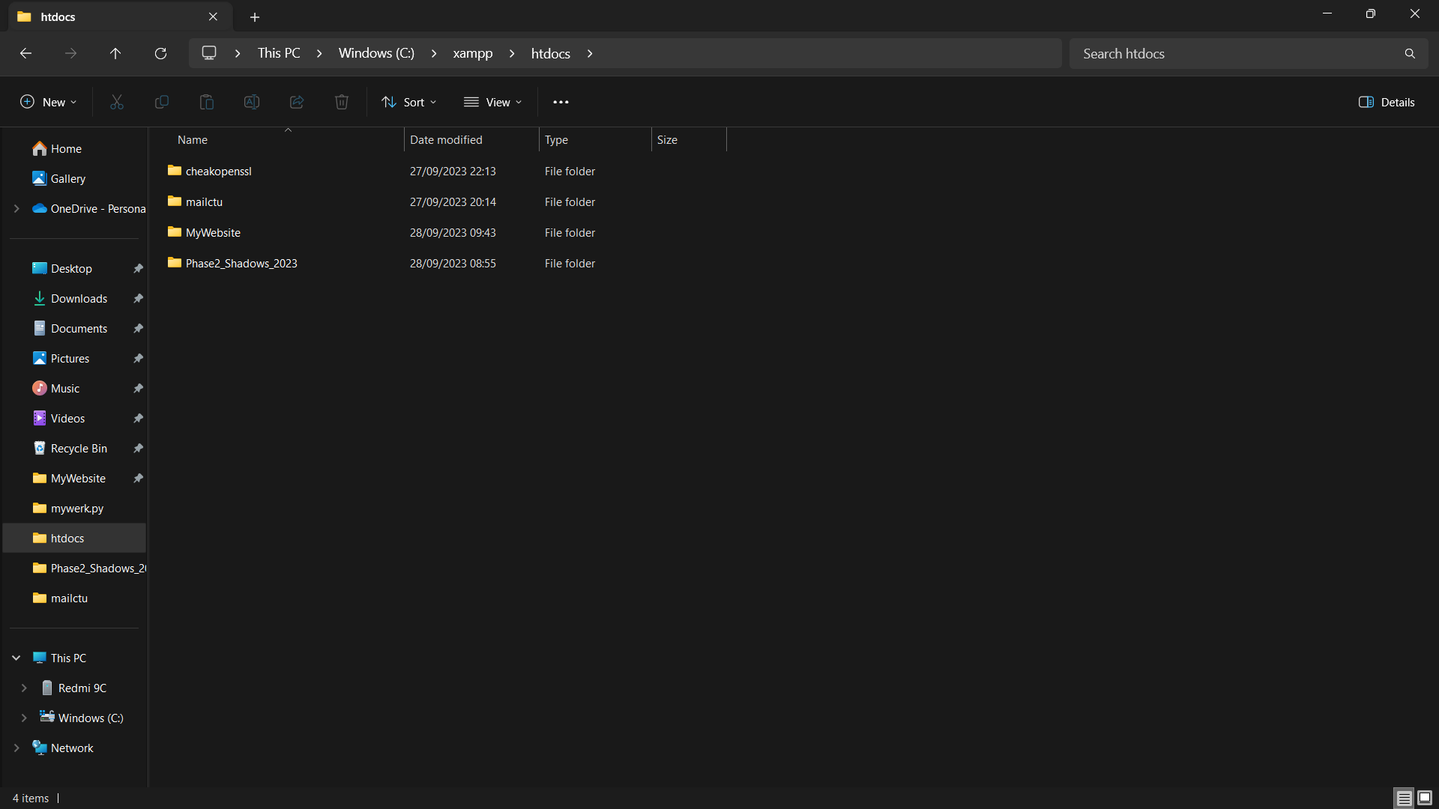

Step2:

Create a new folder and name it uploads, copy the directory of the uploads folder.

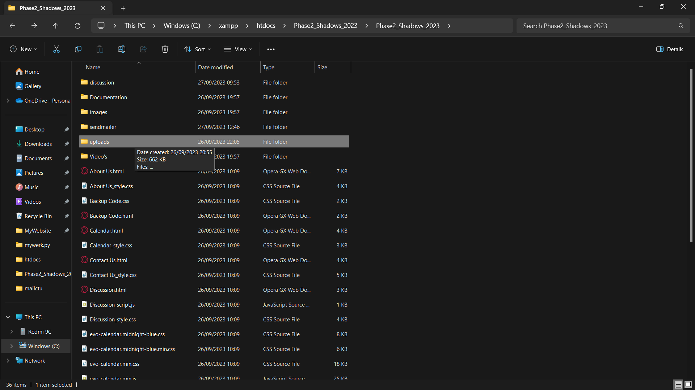

Step3:

Now go to visual studio, create a new file and name it upload. Here is the php code for the upload’s functionality. In the $uploadDir past the upload file directory so that your php code can link your upload folder with the php code.

$uploadDir = 'C:/xampp/htdocs/Phase2_Shadows_2023/Phase2_Shadows_2023/uploads/’; // Absolute path to store uploaded files

if (isset($_POST['resourceName']) && isset($_FILES['resourceFile'])) {

    $resourceName = $_POST['resourceName'];

    $resourceFile = $_FILES['resourceFile'];

    $resourceCategory = $_POST['resourceCategory'];

    $resourceTags = isset($_POST['resourceTags']) ? $_POST['resourceTags'] : '';

    $uploadedFile = $uploadDir . basename($resourceFile['name']);

    if (move_uploaded_file($resourceFile['tmp_name'], $uploadedFile)) {

        // File uploaded successfully.

        echo "File uploaded successfully.";

    } else {

        // Error uploading file.

        echo "Sorry, there was an error uploading your file.";

    }

} else {

    // Invalid request.

    echo "Invalid request.";

}

?>

Step4:

Link your php code with your html.I link my shared Recoures.html with my upload.php.

<!DOCTYPE html>

<html lang="en">

<head>

    <meta charset="UTF-8">

    <meta name="viewport" content="width=device-width, initial-scale=1.0">

    <title>Share Resources</title>

    <link rel="icon" href="images/wall-e.png">

    <link rel="stylesheet" href="Share Resources_style.css">

</head>

<body>

    <div class="header">

        <nav>

            <div class="logo">

                <a href="Home.html"><img width="12%" src="images/wall-e.png" alt=""></a>

                <span>CTU-Buddy</span>

            </div>

            <ul>

                <li><a href="Home.html">Home</a></li>

                <li><a href="Timetable.html">Timetable</a></li>

                <li><a href="Calendar.html">Calendar</a></li>

                <li><a href="Discussion.html">Discussion</a></li>

                <li><a href="Profile.html"><img class="userpro" src="images/usericon.png" alt=""></a></li>

            </ul>

        </nav>

        <div class="container">

            <h1>Share Resources</h1>

            <div class="upload-form">

                <h2>Upload Resource</h2>

                <hr class="hr-mod">

                <form action="upload.php" method="post" enctype="multipart/form-data">

                    <input type="text" name="resourceName" placeholder="Resource Name" required>

                    <input class="button-upload" type="file" name="resourceFile" accept=".pdf" required>

                    <select name="resourceCategory" required>

                        <option value="" disabled selected>Select Category</option>

                        <option value="Robotic Development">RD412</option>

                        <option value="Core Web Development">CW412</option>

                        <option value="Ethics and Networking">EN412</option>

                        <option value="Cloud Fundamentals">CF412</option>

                    </select>

                    <input type="text" name="resourceTags" placeholder="Tags (comma-separated)">

                    <button type="submit">Upload</button>

                </form>

            </div>

            <div class="resource-list">

                <h2>Resources</h2>

                <hr class="hr-mod2">

                <input type="text" id="searchInput" placeholder="Search resources...">

                <ul id="resourceItems">

                    <!-- Resources will be displayed here -->

                </ul>

                <div id="noResultsMsg"></div>

            </div>

        </div>

    </div>

    <footer>

        <p class="custom">This is the Share Resource page of the CTU Buddy Website.</p>

        <p class="custom">This page helps learners to find study guides or any resources needed when studying for an exam.</p>

        <p class="custom">All that needs to be done is to give the resource a name, choose the file, select the correct category, and any tags or comments. Click upload, and the resource will be available for download.</p>

        <p class="custom">Please use the links above to navigate to the other pages.</p>

    </footer>

</body>

</html>

Step5:

Now lets test the website.

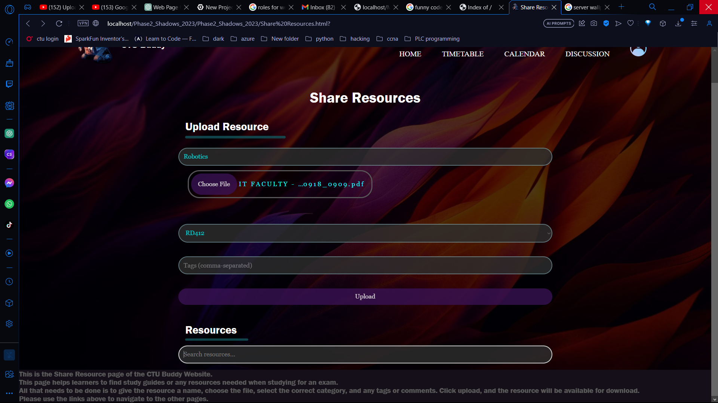

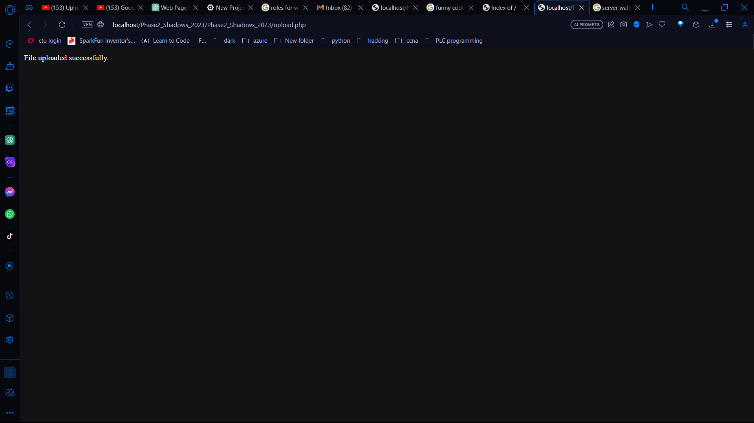

Step6:

Now if we go to your htdocs folder and select your website and Go to your uploads folder we can see that the documents that we uploaded is in the folder.

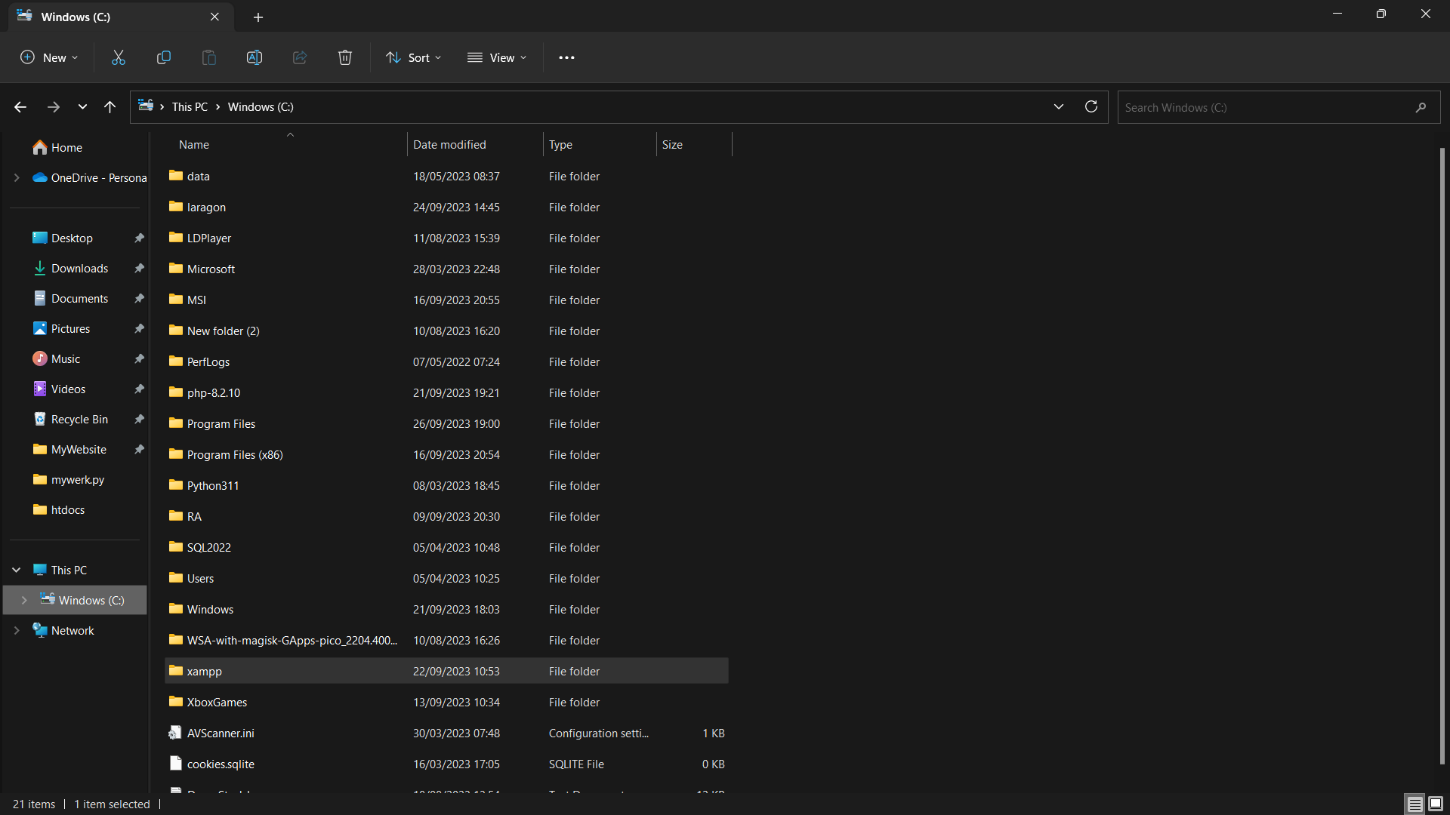

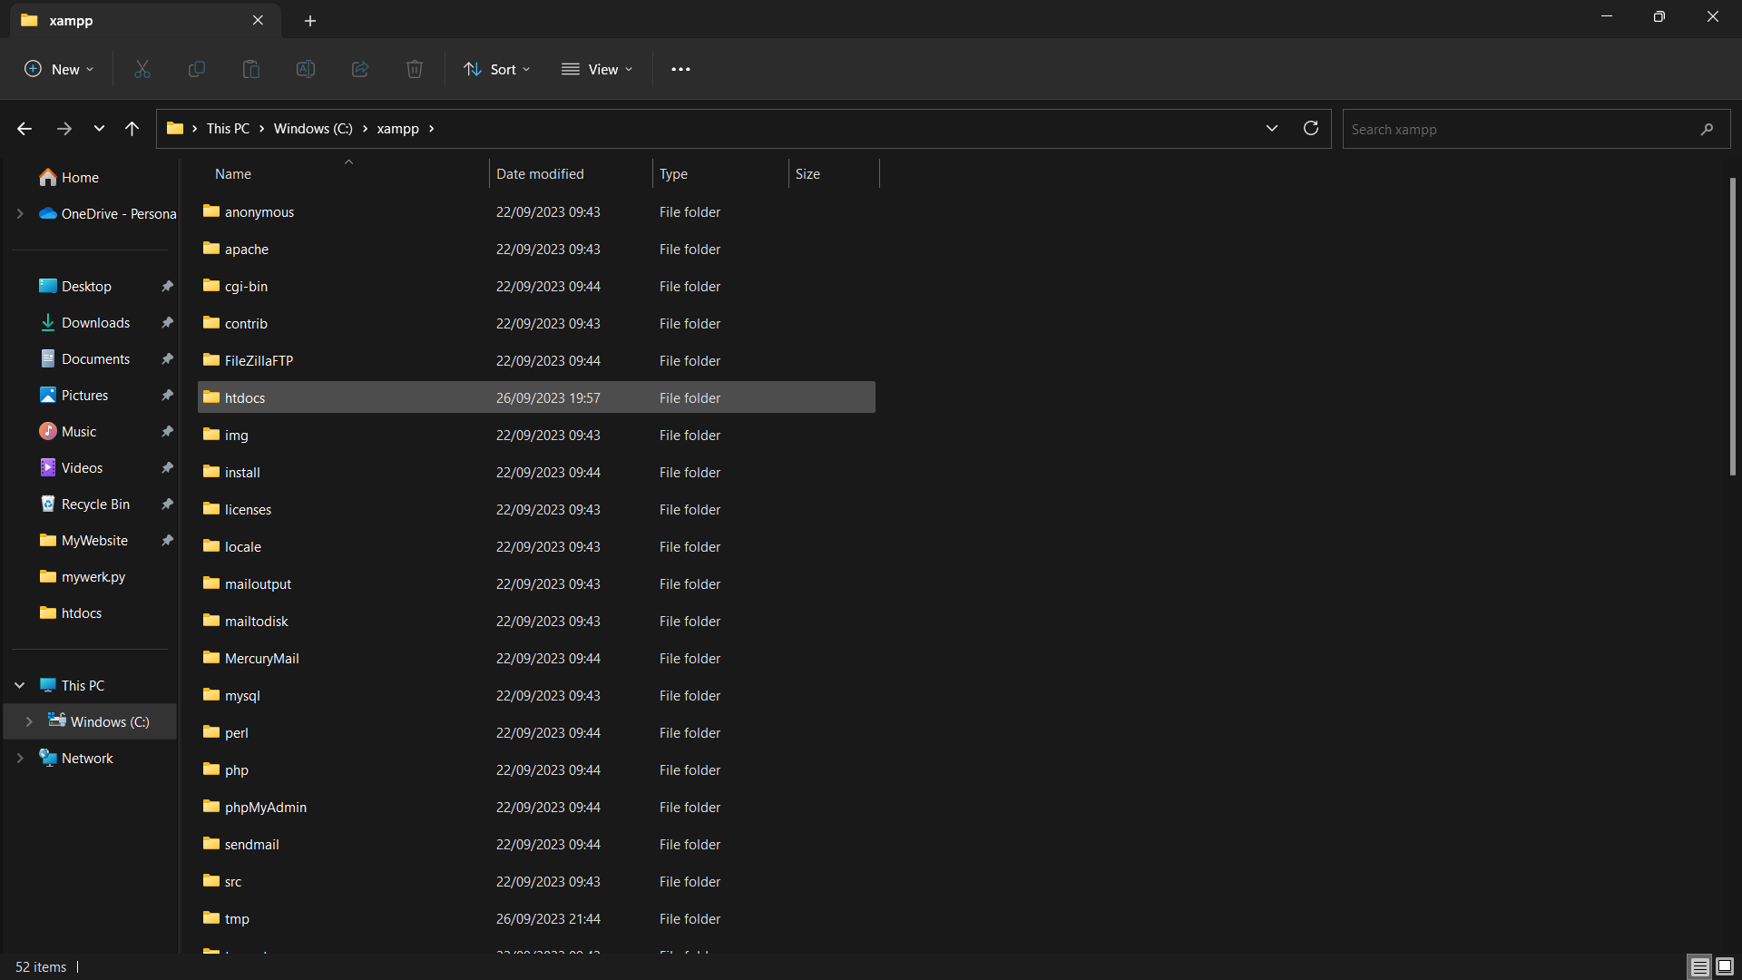

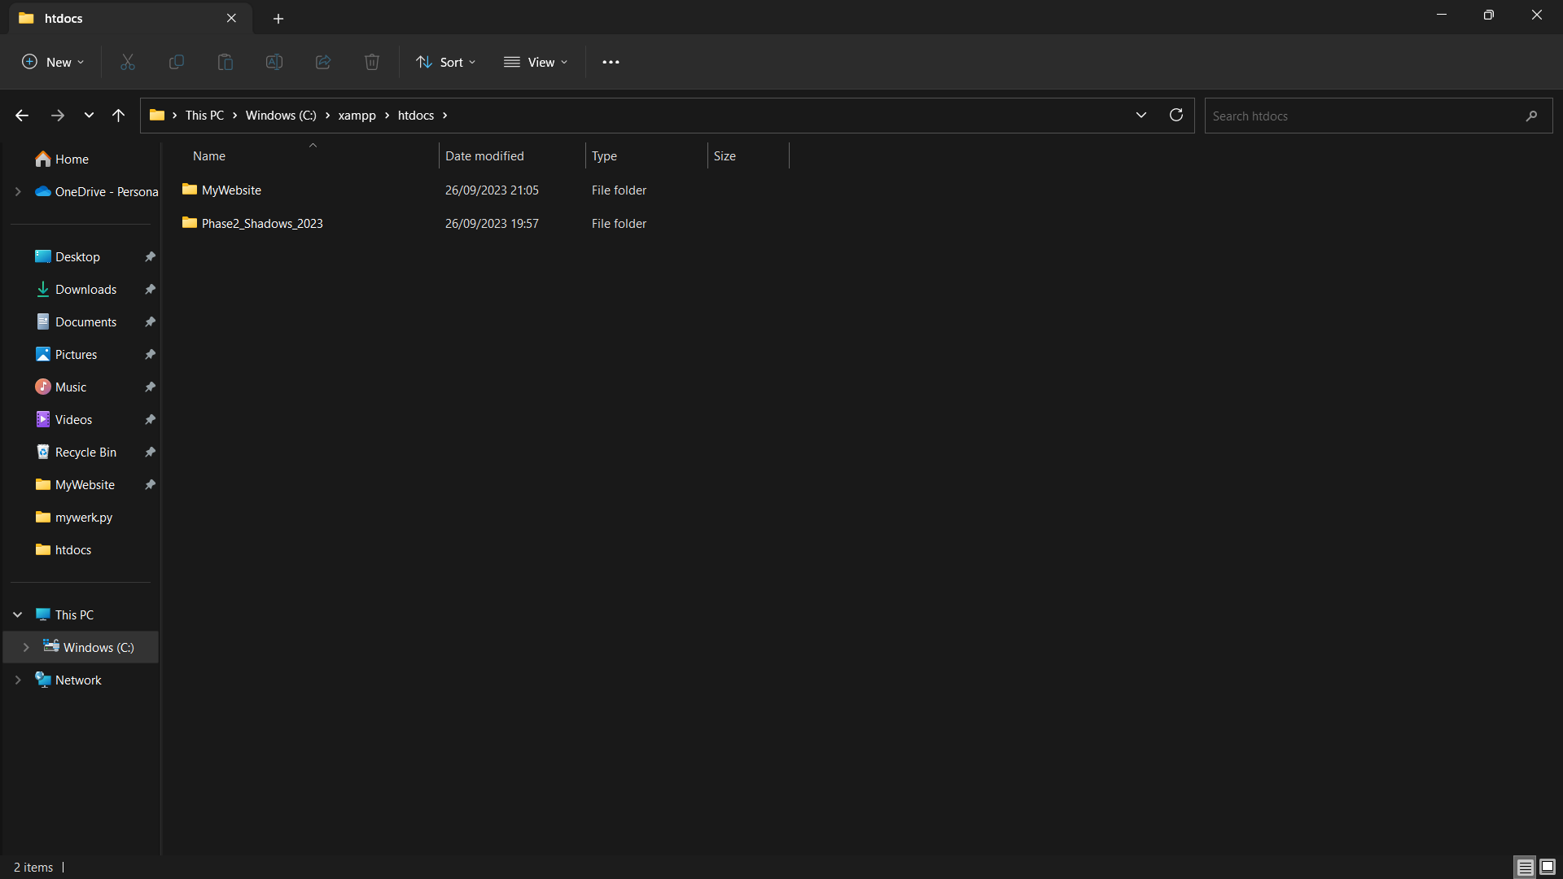

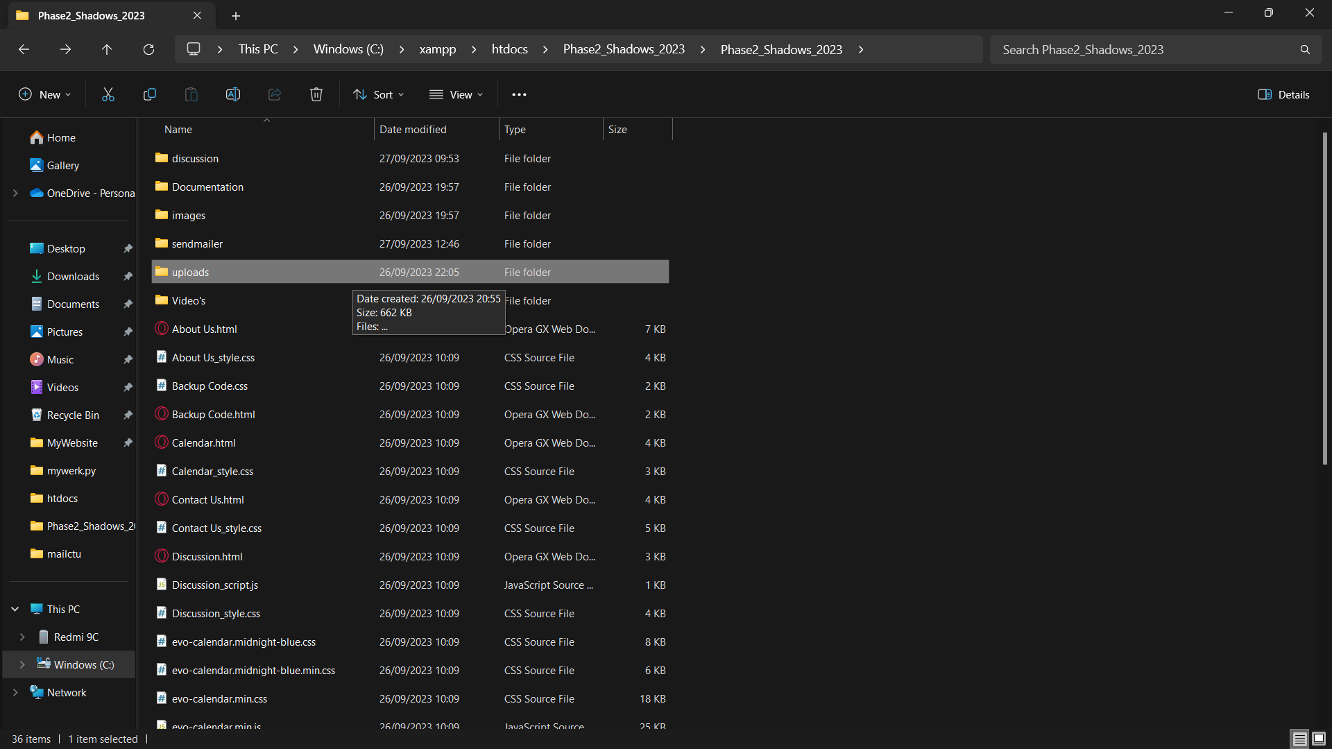

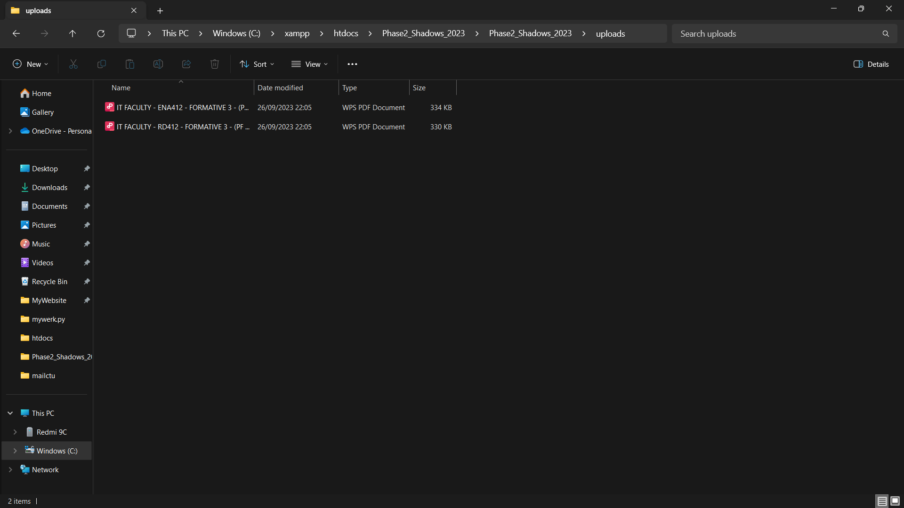

We successfully create the functionality to upload files to our Xamp server.

***Question and comment functionality:***

Step1:

Install Composer (If Not Already Installed):

If you haven't already installed Composer on your system, you can do so by following the instructions on the official Composer website: https://getcomposer.org/download/.

Create a New PHP Project (If Needed):

If you're starting a new PHP project, create a new project directory and navigate to it in your terminal.

Copy code mkdir my_php_project

cd my_php_project

Initialize a Composer Project (If Needed):

If you're starting a new project, you can initialize a new Composer project in your project directory:

Copy code composer init

Follow the prompts to set up your project. Composer will create a composer.json file.

Require PHPMailer:

To download and install PHPMailer, use Composer's require command:

Copy code composer require phpmailer/phpmailer

This command will download PHPMailer and its dependencies and add them to your project.

Now that phpmailer is download we can create our php code:

Step2:

Now lets code your php code:

<?php

use PHPMailer\PHPMailer\PHPMailer;

require_once 'PHPMailer/PHPMailer.php';

require_once 'PHPMailer/SMTP.php';

require_once 'PHPMailer/Exception.php';

// Check if the request contains the necessary POST data

if(isset($_POST['name']) && isset($_POST['email']) && isset($_POST['subject']) && isset($_POST['body'])){

    $name = $_POST['name'];

    $email = $_POST['email'];

    $subject = $_POST['subject'];

    $body = $_POST['body'];

    $mail = new PHPMailer();

    // SMTP Settings

    $mail->isSMTP();

    $mail->Host = "smtp.gmail.com";

    $mail->SMTPAuth = true;

    $mail->Username = "potgieterphilip25@gmail.com"; // Replace with your Gmail email address

    $mail->Password = "plwu iqko phff npbt"; // Replace with your Gmail password

    $mail->Port = 587; // Use TLS port 587

    $mail->SMTPSecure = "tls"; // Use TLS

    // Email Settings

    $mail->isHTML(true);

    $mail->setFrom($email, $name);

    $mail->addAddress("potgieterphilip25@gmail.com"); // Replace with the recipient's email address

    $mail->Subject = $subject;

    $mail->Body = $body;

    $response = array();

    if($mail->send()){

        $response['status'] = "success";

        $response['message'] = "Message sent successfully!";

    }else{

        $response['status'] = "error";

        $response['message'] = "Something is wrong: " . $mail->ErrorInfo;

    }

    // Send a JSON response back to the client

    header('Content-Type: application/json');

    echo json_encode($response);

} else {

    // If POST data is missing, send a JSON response indicating an error

    $response = array(

        'status' => 'error',

        'message' => 'Missing POST data'

    );

    header('Content-Type: application/json');

    echo json_encode($response);

}

?>

This code will allow as to send an email from our local host to our email address.

Step3:

Now we need to link your html with our php code

<!DOCTYPE html>

<html lang="en">

<head>

    <meta charset="UTF-8">

    <meta name="viewport" content="width=device-width, initial-scale=1.0">

    <title>Discussion</title>

    <link rel="icon" href="images/wall-e.png">

    <link rel="stylesheet" href="Discussion_style.css">

</head>

<body>

    <div class="header">

        <nav>

            <div class="logo">

                <a href="Home.html"><img width="12%" src="images/wall-e.png" alt=""></a>

                <span>CTU-Buddy</span>

            </div>

            <ul>

                <li><a href="Index.html">Home</a></li>

                <li><a href="Timetable.html">Timetable</a></li>

                <li><a href="Calendar.html">Calendar</a></li>

                <li><a href="Share Resources.html">Share Resources</a></li>

                <li><a href="Profile.html"><img class="userpro" src="images/usericon.png" alt=""></a></li>

            </ul>

        </nav>

        <div class="container">

            <h1 class="form-head">CTU-Buddy Discussion Form</h1>

            <div class="discussion">

                <hr class="hr-mod">

                <!-- Email Functionality -->

                <div class="email-section">

                    <h2 class="email-header">Send an Email</h2>

                    <form id="emailForm" action="sendEmail.php" method="POST">

                        <label>Name</label>

                        <input id="name" type="text" name="name" placeholder="Enter Name" required>

                        <label>Email</label>

                        <input id="email" type="text" name="email" placeholder="Enter Email" required>

                        <label>Subject</label>

                        <input id="subject" type="text" name="subject" placeholder="Enter Subject" required>

                        <p>Message</p>

                        <textarea id="body" name="body" rows="5" placeholder="Enter Message" required></textarea>

                        <button type="submit">Send</button>

                    </form>

                    <h4 class="sent-notification"></h4>

                </div>

            </div>

        </div>

        <script>

            // Get the form element

            var emailForm = document.getElementById("emailForm");

            // Add a submit event listener to the form

            emailForm.addEventListener("submit", function (event) {

                event.preventDefault(); // Prevent the default form submission behavior

                // Get form elements by their IDs

                var name = document.getElementById("name");

                var email = document.getElementById("email");

                var subject = document.getElementById("subject");

                var body = document.getElementById("body");

                if (isNotEmpty(name) && isNotEmpty(email) && isNotEmpty(subject) && isNotEmpty(body)) {

                    // Create a new FormData object to send the form data

                    var formData = new FormData(emailForm);

                    // Send a POST request using the Fetch API

                    fetch("sendEmail.php", {

                        method: "POST",

                        body: formData

                    })

                    .then(function (response) {

                        return response.json(); // Parse the JSON response

                    })

                    .then(function (data) {

                        emailForm.reset(); // Reset the form

                        document.querySelector(".sent-notification").textContent = data.message; // Display the response message

                    })

                    .catch(function (error) {

                        console.error(error); // Handle any errors that occurred during the fetch

                    });

                }

            });

            function isNotEmpty(inputElement) {

                if (inputElement.value === "") {

                    inputElement.style.border = "3px solid red";

                    return false;

                } else {

                    inputElement.style.border = "3px solid green";

                    return true;

                }

            }

        </script>

    </div>

    <footer>

        <p id="custom">This is the Discussion page of the CTU Buddy Website.</p>

        <p id="custom">The Discussion page is for students to ask questions or address concerns and receive feedback.</p>

        <p id="custom">First insert your name, next type in your email. Then state what subject you are talking about and last enter your message.</p>

        <p id="custom">Please use the links above to navigate to the other pages.</p>

    </footer>

</body>

</html>

Here is the css of the dicussio.html

/* Reset CSS */

* {

  margin: 0;

  padding: 0;

  box-sizing: border-box;

  font-family: 'poppins', sans-serif;

}

/* Set text color of h2 to white */

.email-section h2 {

  color: white;

}

/* Header and Navigation Styling */

.header {

  width: 100%;

  height: 100vh;

  background-image: linear-gradient(rgba(0, 0, 0, 0.7), rgba(0, 0, 0, 0.7)), url(images/discussion_back.jpg);

  background-position: center;

  background-size: cover;

  overflow-x: hidden;

}

/* Set heading text color to white */

.form-head {

  text-align: center;

  margin-top: 30px;

  color: white; /* Add this line to set the text color to white */

}

.nav-bottom {

  background: rgb(7, 31, 33);

  border-radius: 0px;

  opacity: 80%;

}

nav {

  width: 100%;

  display: flex;

  justify-content: space-between;

  align-items: center;

  padding: 18px 8%;

  transition: background 1s;

}

/* Logo Styling */

.nav .logo {

  display: flex;

  align-items: center;

  font-size: 20px;

  font-weight: 600;

  color: #d7d3d3;

}

.nav .logo img {

  width: 90px;

  margin-right: 10px;

}

/* Navigation Links Styling */

nav ul li {

  display: inline-block;

  list-style: none;

  margin: 10px 20px;

}

nav ul li a {

  text-decoration: none;

  color: #ffff;

  font-weight: 500;

  padding: 5px 20px;

  text-transform: uppercase;

  font-family: 'poppins';

}

nav:hover{

  background: rgb(7, 31, 33);

  border-radius: 50px;

  opacity: 80%;

}

nav:hover .logo{

  color: #ffff;

  opacity: 100%;

}

nav:hover ul li a{

    /* background: #0d0d0d; */

    color: #ffff;

    opacity: 100%;

}

/* Container and Form Styling */

.container {

  width: 800px;

  margin: 0 auto;

}

.form-head {

  text-align: center;

  margin-top: 30px;

}

.hr-mod {

  margin-top: -8px;

  margin-left: 10px;

  margin-bottom: 15px;

  width: 580px;

  height: 5px;

  border-radius: 20px;

  border: none;

  background: rgb(19, 84, 90);

  opacity: 80%;

}

.email-section {

  margin-top: 30px;

  background-color: rgba(0, 0, 0, 0.7);

  padding: 20px;

  border-radius: 10px;

}

.email-header {

  font-size: 24px;

  margin-bottom: 15px;

}

/* Form Field Styling */

label {

  color: white;

  font-weight: bold;

  margin-bottom: 5px;

}

input[type="text"],

textarea {

  width: 100%;

  padding: 10px;

  background-color: rgba(255, 255, 255, 0.1);

  border: 2px solid wheat;

  border-radius: 40px;

  margin-bottom: 10px;

  color: white;

}

/* Button Styling */

button {

  font-family: fantasy;

  font-size: 20px;

  letter-spacing: 10px;

  padding: 5px 30px;

  background: rgb(56, 17, 83);

  margin-left: 15px;

  color: white;

  border: none;

  border-radius: 25px;

  cursor: pointer;

  transition: background 0.3s ease-in-out;

}

button:hover {

  background: rgb(14, 62, 66);

}

/* Post Styling (if applicable) */

.post {

  background: rgb(9, 38, 41);

  opacity: 80%;

  padding: 10px;

  border: 2px solid wheat;

  border-radius: 25px;

  margin-bottom: 10px;

}

.post .username {

  font-weight: bold;

  margin-bottom: 5px;

}

.post .content {

  margin-bottom: 5px;

}

/* Footer Styling (if applicable) */

footer {

  margin-top: 60px;

  width: auto;

  height: auto;

  opacity: 30%;

  background-color: rgb(24, 7, 35);

}

footer:hover {

  opacity: 10%;

  transition: 1s;

}

#custom {

  font-size: 13px;

  padding: 2px;

  font-family: Arial, Helvetica, sans-serif;

  letter-spacing: 2px;

  border: 1px solid teal;

}

.userpro {

  width: 35px;

  margin-top: 20px;

  margin-left: 0px;

}

Step4: now we need to create an email for your website.

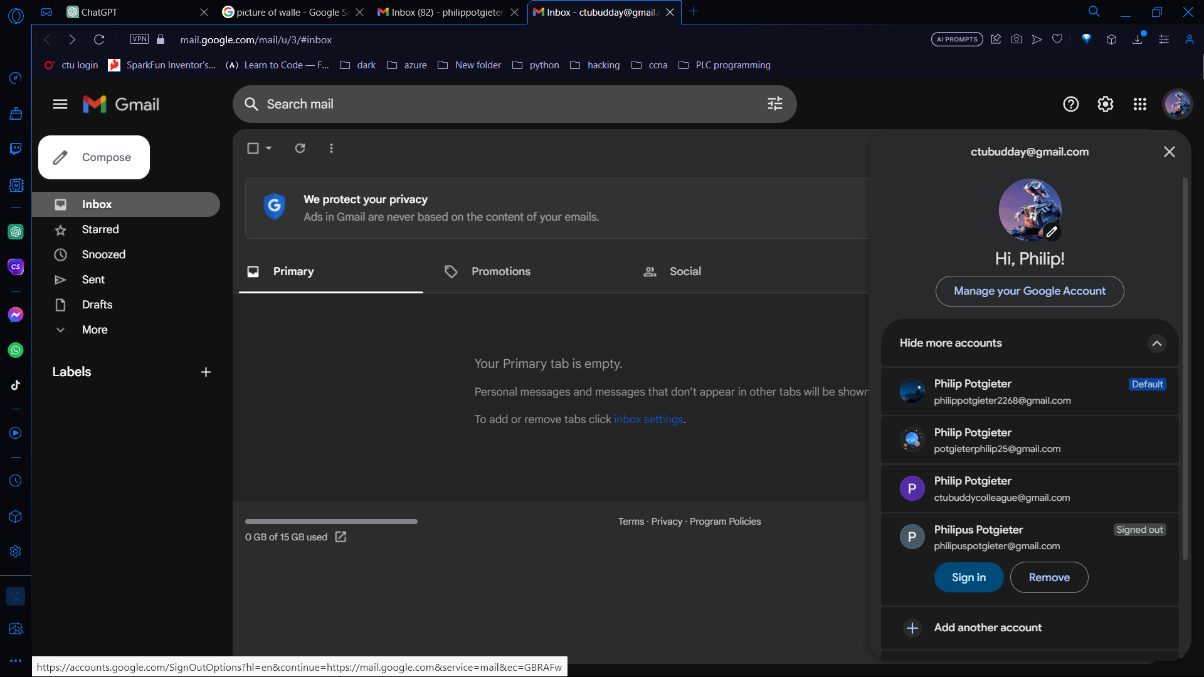

Step5:

We need to test your website.

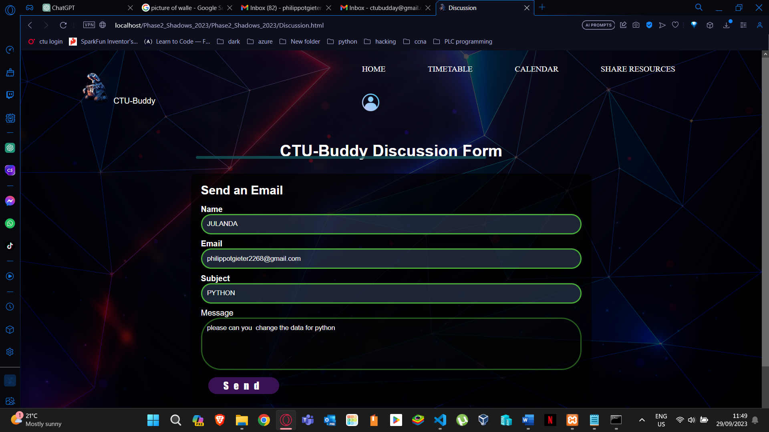

As you can see the email was successfully sent.

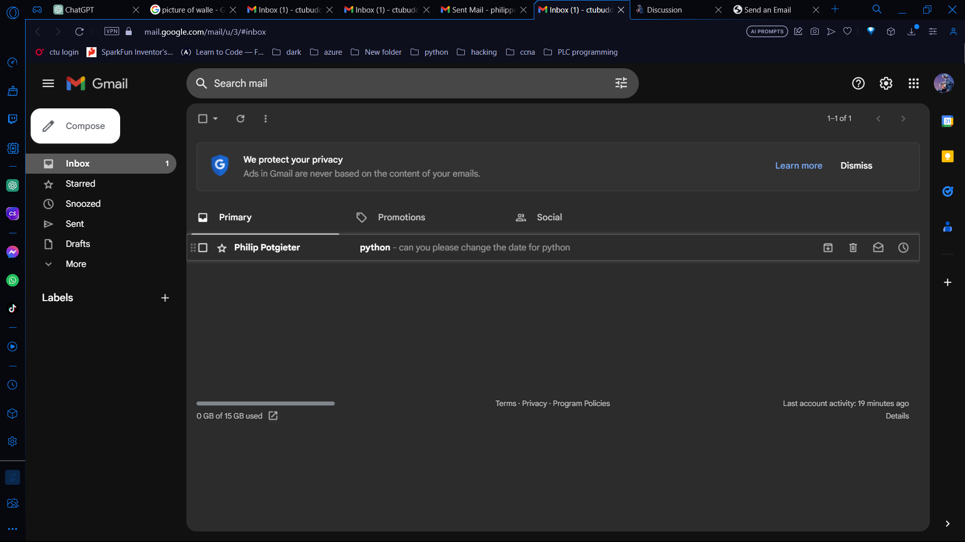

Subscribe functionality:

Step1:

We will need to add a subscribe button under the submit button:

<!DOCTYPE html>

<html lang="en">

<head>

    <meta charset="UTF-8">

    <meta name="viewport" content="width=device-width, initial-scale=1.0">

    <title>Contact US</title>

    <link rel="icon" href="images/wall-e.png">

    <link rel="stylesheet" href="Contact Us_style.css">

    <script src="https://kit.fontawesome.com/edbade1029.js" crossorigin="anonymous"></script>

</head>

<body>

    <div class="header">

        <nav>

          <div class="logo">

            <a href="Home.html"><img width="12%" src="images/wall-e.png" alt=""></a>

              <span>CTU-Buddy</span>

          </div>

          <ul>

              <li><a href="Home.html">Home</a></li>

              <!-- <li><a href="Timetable.html">Timetable  </a></li>

              <li><a href="Discussion.html">Discussion</a></li> -->

              <!-- <li><a href="Share Resources.html">Share Resources</a></li> -->

              <li><a href="About Us.html">About us</a></li>

              <!-- <li><a href="Contact Us.html">Contact us</a></li> -->

              <li><a href="Profile.html"><img class="userpro" src="images/usericon.png" alt=""></a></li>

          </ul>

        </nav>

        <div class="headerF">

          <img class="ctu-location" src="images/ctu_locations.jpg" alt="">

           <form>

            <!-- <p class="p-contact">kjdfhgkhjdf</p>

            <p class="p-contact">kjdfhgkhjdf</p>

            <p class="p-contact">kjdfhgkhjdf</p> -->

                <div class="row">

                    <div class="input-group">

                        <input type="text" id="name" required>

                        <label for="name"><i class="fa-solid fa-user"></i> Your Name </label>

                    </div>

                    <div class="input-group">

                        <input type="phone" id="phone"

                        pattern="[0-9]{3}[0-9]{3}[0-9]{4}" required>

                        <label for="phone"><i class="fa-solid fa-phone"></i> Phone No. </label>

                    </div>

                </div>

                <div class="input-group">

                    <input type="email" id="email" required>

                    <label for="email"><i class="fa-solid fa-envelope"></i> Email </label>

                </div>

                <div class="input-group">

                    <textarea id="message" rows="8" required></textarea>

                    <label for="message"><i class="fa-solid fa-comments"></i> Your Message</label>

                </div>

                <button type="submit">SUBMIT <i class="fa-regular fa-paper-plane"></i></button>

                <button type="button" onclick="window.location.href='http://localhost/Phase2_Shadows_2023/subscribe.html'">Subscribe</button>

            </form>

        </div>

    </div>

    <div class="sidebar">

        <header>Shadows</header>

        <ul>

            <li><i>Sebastian van Zyl | 20230301</i></li>

            <li><i>Tayla Potgieter   | 20231256</i></li>

            <li><i>Philip Potgieter  | 20231860</i></li>

        </ul>

        <!-- <input type="checkbox" name="Check Box" id="check">

        <label for="check">

            <i class ="fas fa-bars" id="btn"></i>

            <i class ="fas fa-times" id="cancel"></i>

        </label> -->

    </div>

    <footer>

        <p id="custom">This is the Contact Us page of the CTU Buddy Website.</p>

        <p id="custom">Here is map to show all campuses around South Africa. </p>

        <p id="custom">Please leave your name and email and phone number with your message.</p>

        <p id="custom">Please Note the profile icon in the top right corner. This is used by students to navigate to their user profile.</p>

    </footer>

</body>

</html>

Step2:

We will need to add the php to the html

<?php

if ($_SERVER["REQUEST_METHOD"] == "POST") {

    $email = $_POST["email"];

    // Here, you can add code to validate the email address and store it in a database.

    // For now, let's just display a thank you message.

    echo "<div class='container'>";

    echo "<h1>Thank You!</h1>";

    echo "<p>You have successfully subscribed to our newsletter.</p>";

    echo "</div>";

}

?>

Step3:

Now we need to add our css

body {

    font-family: Arial, sans-serif;

    background-color: #f4f4f4;

}

.container {

    max-width: 400px;

    margin: 0 auto;

    padding: 20px;

    background-color: #fff;

    border-radius: 5px;

    box-shadow: 0 0 10px rgba(0, 0, 0, 0.1);

    text-align: center;

}

h1 {

    color: #333;

}

p {

    color: #666;

    margin-bottom: 20px;

}

form {

    text-align: center;

}

label {

    display: block;

    margin-bottom: 10px;

    color: #333;

}

input[type="email"] {

    width: 100%;

    padding: 10px;

    border: 1px solid #ccc;

    border-radius: 5px;

    font-size: 16px;

}

button {

    background-color: #007bff;

    color: #fff;

    border: none;

    border-radius: 5px;

    padding: 10px 20px;

    font-size: 18px;

    cursor: pointer;

}

button:hover {

    background-color: #0056b3;

}

Step4:

We need to test that everything is working, Go to your web browser and type in localhost and then select your websites name and Go to contact us.

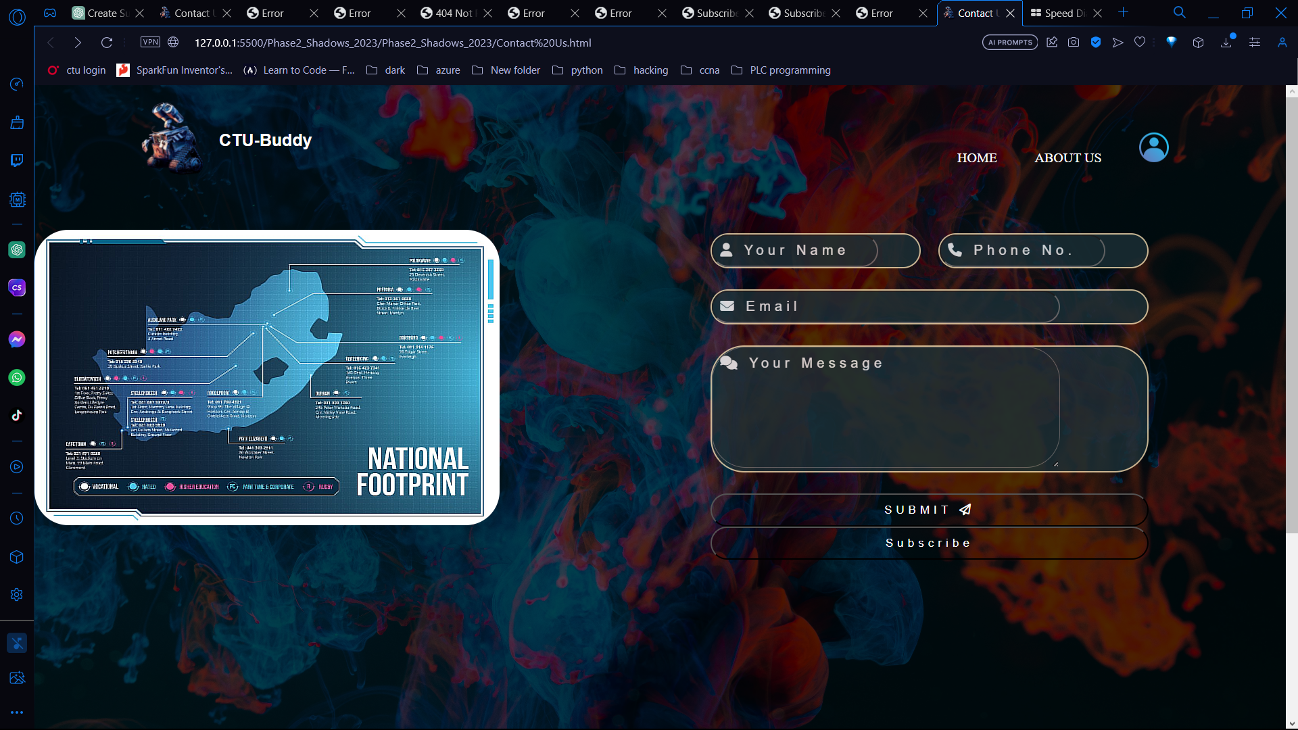

Once you click on the button the web page will take you to the subscribe page

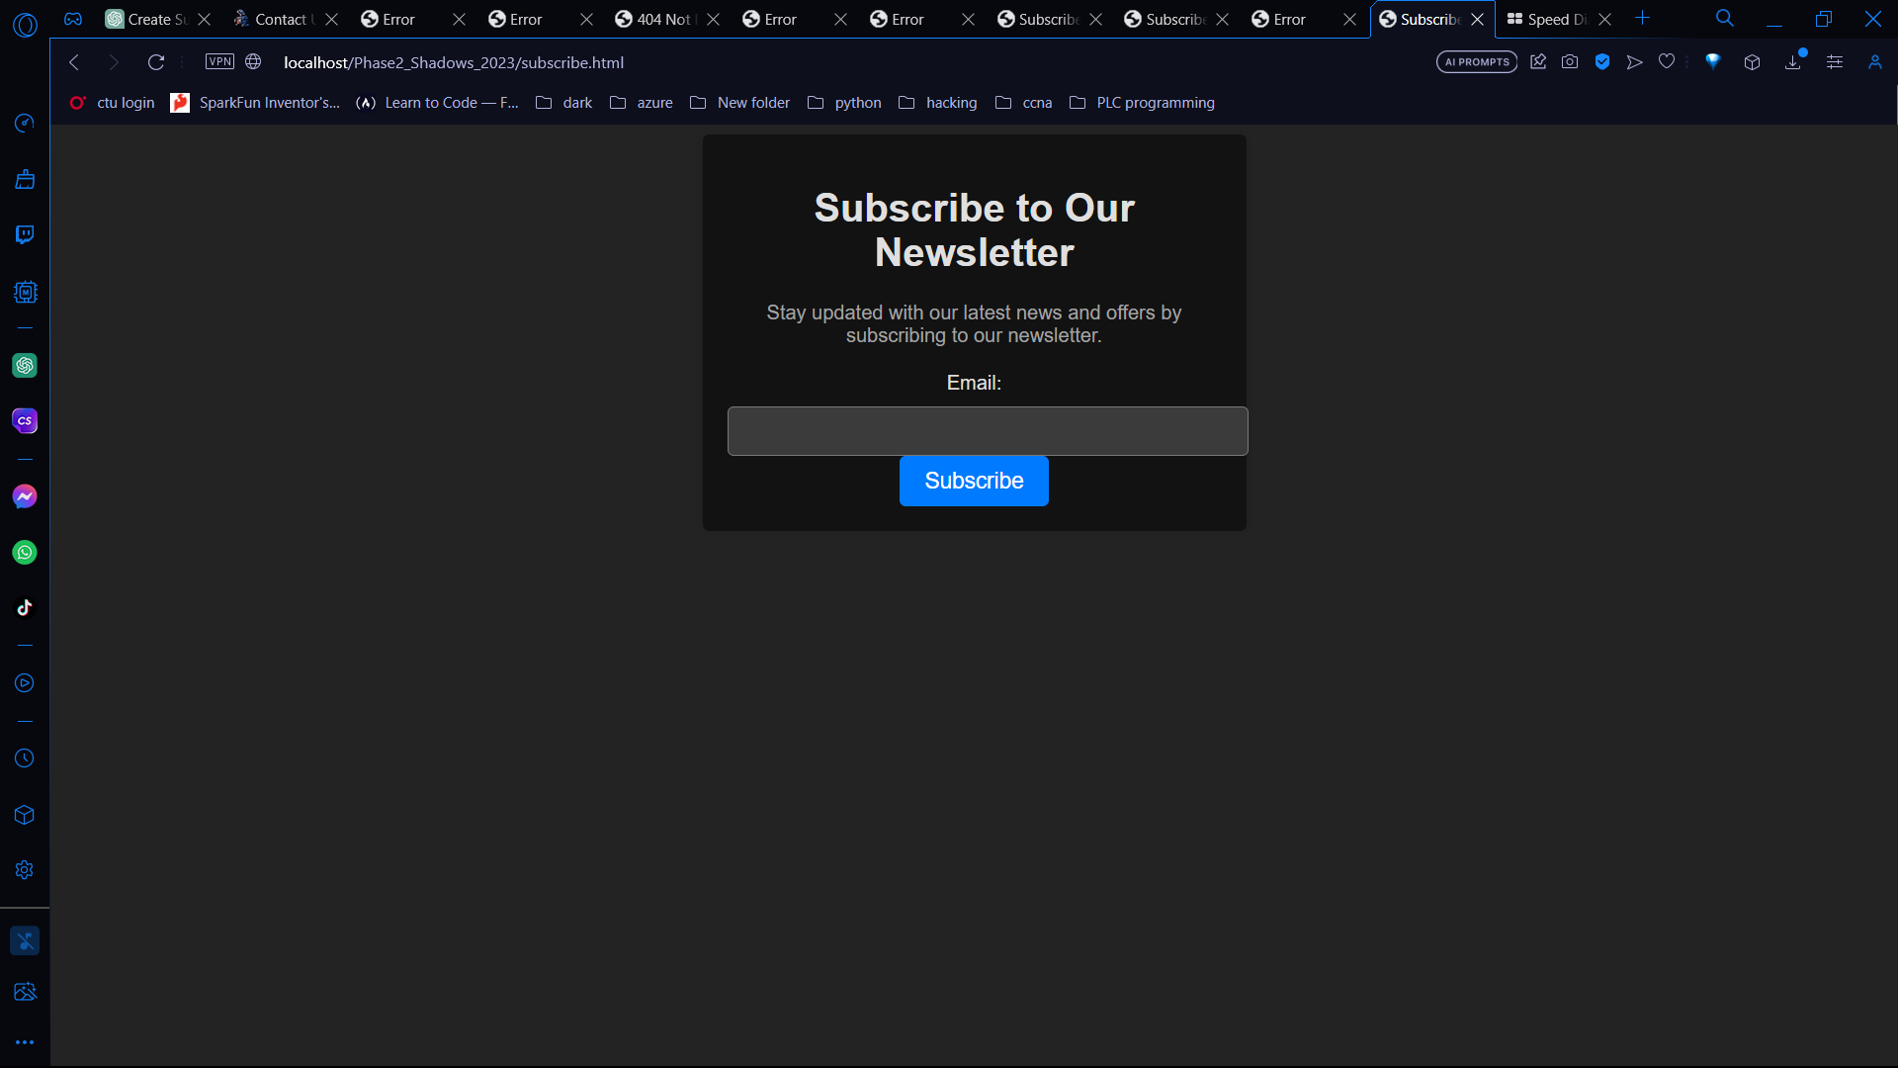

Enter your email and you will subscribe to your newsletter.

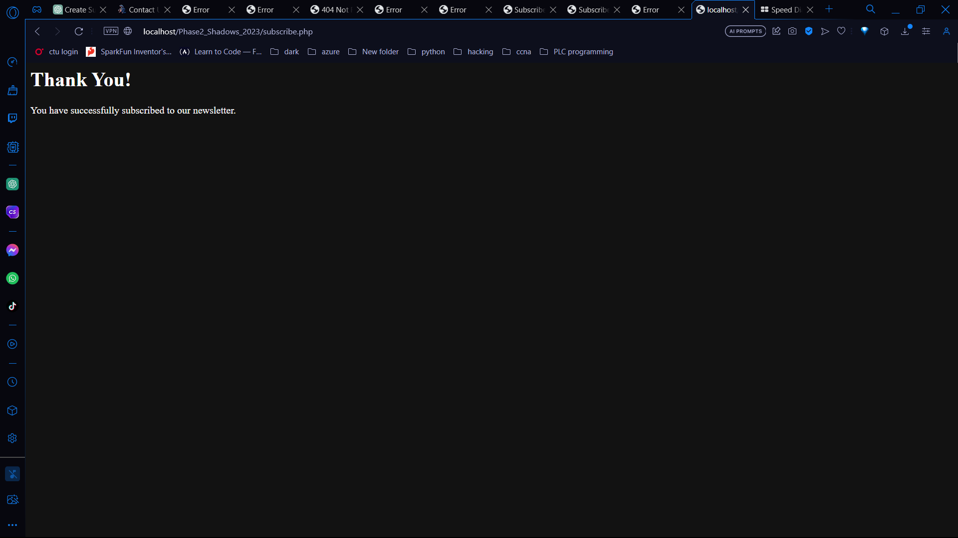

**Completed Declaration of Authenticity**

I PHILIPUS MARTHINUS POTGIETER _ hereby

(FULL NAME)

declare that the contents of this assignment are entirely my own work except for the following documents: (List the documents and page numbers of work in this portfolio

that were generated in a group)

|  |  |
| --- | --- |
| **Activity** | **Date** |
|  |  |
|  |  |
|  |  |
|  |  |
|  |  |
|  |  |

Signature: PM POTGIETER Date:              29/09/2023